CSE1007 – JAVA Programming

Lab Exercise on Arrays

**Question 1**

One of the leading newspapers wants to display the Olympic medals tally on its online edition with few additional features:

1. i) To print the countrywise total
2. ii) To print medalwise total
3. iii) Display India’s current position

For each of the above, design a method and the method signature is given below:

*int countryTotal (String countryName, int[][] medalTally);*

*int medalTotal (String medalType, int[][] medalTally);*

*int position (int[][] medalTally);*

Devise a JAVA application to test the above methods.

**CODE:**

import java.util.Scanner;

public class q1 {

public static int countryTotal (String countryName, int[][] medalTally, String[] countries)

{

int i=0, total=0;

for (String s : countries )

{

if(s.equals(countryName))

total=medalTally[i][0]+medalTally[i][1]+medalTally[i][2];

i++;

}

return total;

}

public static int medalTotal (String medalType, int[][] medalTally, String[] countries, int i)

{

int type=0;

if (medalType.equals("Gold"))

type=0;

else if (medalType.equals("Silver"))

type=1;

else if (medalType.equals("Bronze"))

type=2;

return medalTally[i][type];

}

public static int position (int[][] medalTally, String[] countries, String countryName)

{

int i=0, pos=0;

for (String s : countries )

{

if(s.equals(countryName))

pos=i+1;

i++;

}

return pos;

}

public static void swap(int a, int b, int x, int[][]A)

{

int temp;

temp=A[a][x];

A[a][x]=A[b][x];

A[b][x]=temp;

}

public static void swap(int a, int b, String[] S)

{

String temp;

temp=S[a];

S[a]=S[b];

S[b]=temp;

}

public static void sortPosition(String[] S, int[][] A, int n)

{

int i,j;

for(i=0;i<n-1;i++)

{

for(j=i+1;j<n;j++)

{

if(A[i][0]<A[j][0])

{

swap(i,j,0,A);

swap(i,j,1,A);

swap(i,j,2,A);

swap(i,j,S);

}

else if(A[i][0]==A[j][0] && A[i][1]<A[j][1])

{

swap(i,j,0,A);

swap(i,j,1,A);

swap(i,j,2,A);

swap(i,j,S);

}

else if(A[i][0]==A[j][0] && A[i][1]==A[j][1] && A[i][2]<A[j][2])

{

swap(i,j,0,A);

swap(i,j,1,A);

swap(i,j,2,A);

swap(i,j,S);

}

}

}

}

public static void print(String[] names,int medals[][],int[] total, int n)

{

int i;

System.out.println(String.format("\n%s %s %s %s %s %s","Position"," Country "," Gold "," Silver "," Bronze "," Total"));

for(i=0;i<n;i++)

{

System.out.print(String.format("%4d",(i+1)));

System.out.print(String.format(" %-5s",names[i]));

System.out.println(String.format("%7d %7d %7d %10d",medals[i][0],medals[i][1],medals[i][2],total[i]));

}

}

public static void main(String args[]) {

Scanner in = new Scanner(System.in);

int n, i;

System.out.print("Enter no: of countries: ");

n=in.nextInt();

String[] names = new String[n];

int[][] medals = new int[n][3];

for(i=0;i<n;i++)

{

System.out.print("\nEnter name of country-"+(i+1)+" : ");

names[i]=in.next();

System.out.print("Enter no:of gold medals : ");

medals[i][0]=in.nextInt();

System.out.print("Enter no:of silver medals : ");

medals[i][1]=in.nextInt();

System.out.print("Enter no:of bronze medals : ");

medals[i][2]=in.nextInt();

}

sortPosition(names,medals,n);

int[]total=new int[n];

for(i=0;i<n;i++)

total[i]=countryTotal(names[i], medals, names);

print(names,medals,total,n);

int ch, c;

String s, type="";

while(true)

{

System.out.println("\n1.Countrywise total 2.Medalwise total 3.Country position 4.Exit");

System.out.print("Enter your choice: ");

ch=in.nextInt();

if(ch==1)

{

System.out.print("Enter country name: ");

s=in.next();

System.out.println("Total medals for "+s+" : "+countryTotal(s, medals, names));

}

else if(ch==2)

{

System.out.println("1.Gold 2.Silver 3.Bronze");

System.out.print("Enter Medal Type name: ");

c=in.nextInt();

if(c==1)

type="Gold";

else if(c==2)

type="Silver";

else if(c==3)

type="Bronze";

System.out.println(String.format("\n%s %s"," Country ",type));

for(i=0;i<n;i++)

{

System.out.print(String.format(" %5s",names[i]));

System.out.println(String.format(" %7d",medalTotal (type, medals, names,i)));

}

}

if(ch==3)

{

System.out.print("Enter country name: ");

s=in.next();

System.out.println("Position of "+s+" : "+position (medals, names, s));

}

else if(ch==4)

break;

}

}

}

**OUTPUT:**

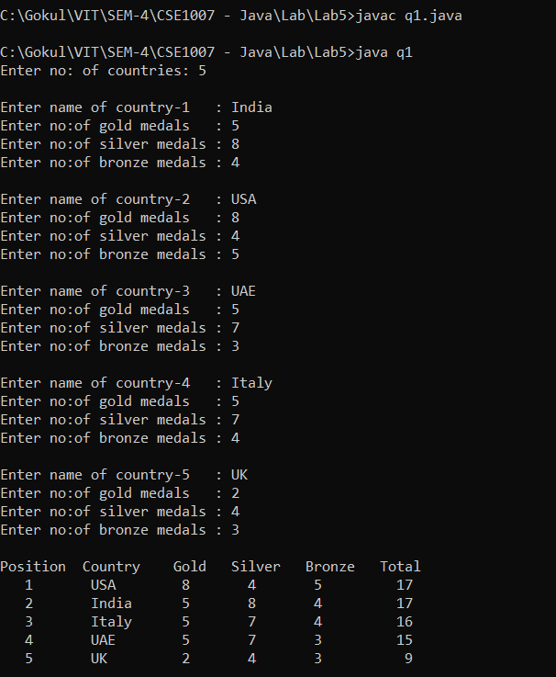

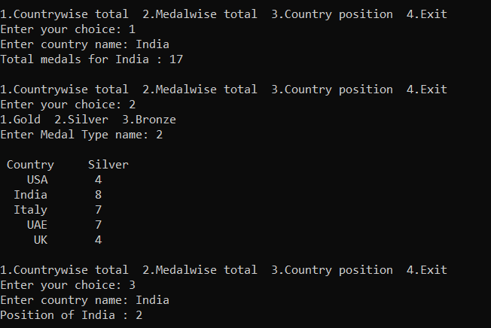

**Question 2**

The daily maximum temperatures recorded in 10 cities during the month of January. Write a Java application to read the table elements into a 2-dimensional array temperature and to find the city and day corresponding to highest temperature and lowest temperature.

**CODE:**

import java.util.Scanner;

public class q2 {

public static int high (int[] temp, int n)

{

int i, max=temp[0];

for(i=1;i<n;i++)

{

if(temp[i]>max)

max=temp[i];

}

return max;

}

public static int low (int[] temp, int n)

{

int i, min=temp[0];

for(i=1;i<n;i++)

{

if(temp[i]<min)

min=temp[i];

}

return min;

}

public static void main(String args[]) {

Scanner in = new Scanner(System.in);

int n, i, j, d;

System.out.print("Enter no: of cities: ");

n=in.nextInt();

System.out.print("Enter no: of testable days: ");

d=in.nextInt();

System.out.println();

int[][] A = new int[n][d];

for(i=0;i<n;i++)

{

System.out.print("Enter "+d+" days' temp of city-"+(i+1)+": ");

for(j=0;j<d;j++)

A[i][j]=in.nextInt();

}

System.out.println();

for(i=0;i<n;i++)

System.out.println("City-"+(i+1)+": High: "+high(A[i],d)+" Low: "+low(A[i],d));

}

}

**OUTPUT:**

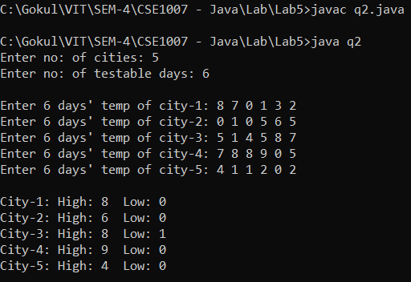

**Question 3**

An election is contested by 5 candidates, the candidates are numbered from 1 to 5 and the voting is done by making the candidate number on the ballot paper. Write a Java application to read the ballots and count the votes cast for each candidate using an array variable count. In case, a number read is outside the range 1 to 5, the ballot should be considered as a “Spoilt ballot” and program should also count the no. of spoilt ballots.

**CODE:**

import java.util.Scanner;

public class q3 {

public static void showCount(int[] count,int n, int spoilt)

{

int i;

System.out.println("Candidate Votes");

for(i=0;i<n;i++)

System.out.println(String.format("%s-%d %5d","Candidate",(i+1),count[i]));

System.out.println(String.format("%s %10d","Spoilt",spoilt));

}

public static void main(String args[]) {

Scanner in = new Scanner(System.in);

int n, i, ch, vote;

System.out.print("Enter no: of candidates: ");

n=in.nextInt();

int[] count=new int[n];

int spoilt=0;

for(i=0;i<n;i++)

count[i]=0;

while(true)

{

System.out.println("\n1.Cast Vote 2.Show Count 3.Exit");

System.out.print("Enter your choice: ");

ch=in.nextInt();

if(ch==1)

{

System.out.print("Enter your choice from (1 to "+n+"): ");

vote=in.nextInt();

if(vote>=1 && vote<=n)

count[vote-1]++;

else

spoilt++;

}

else if(ch==2)

showCount(count,n,spoilt);

else if(ch==3)

break;

}

}

}

**OUTPUT:**

